ASSIGNMENT 1: SQL MASTERY - The E-Commerce Analytics Challenge
Topics Covered
SQL Manipulation, Retrieval, Aggregation, Joins, Subqueries, CTEs, Window Functions, Stored Procedures, Indexes
Duration: 7–8 Hours
Questions: 30
Problem Statement
You're hired as a Data Engineer at "ShopHub" – a fast-growing e-commerce platform. The company has raw transactional data scattered across multiple systems. Your job is to design, optimize, and create a complete analytics database.
Dataset
Brazilian E-Commerce Public Dataset by Olist
Dataset Link:
https://www.kaggle.com/datasets/olistbr/brazilian-ecommerce
Dataset Size: ~100K orders, 8 CSV files (~45 MB)
Files Included:
- customers
- orders
- order_items
- products
- sellers
- order_payments
- order_reviews
- geolocation

Assignment Questions
Part A: Database Design & Data Quality (5 Questions)
- Design a normalized database schema (3NF) with ERD showing all relationships between 8 tables.
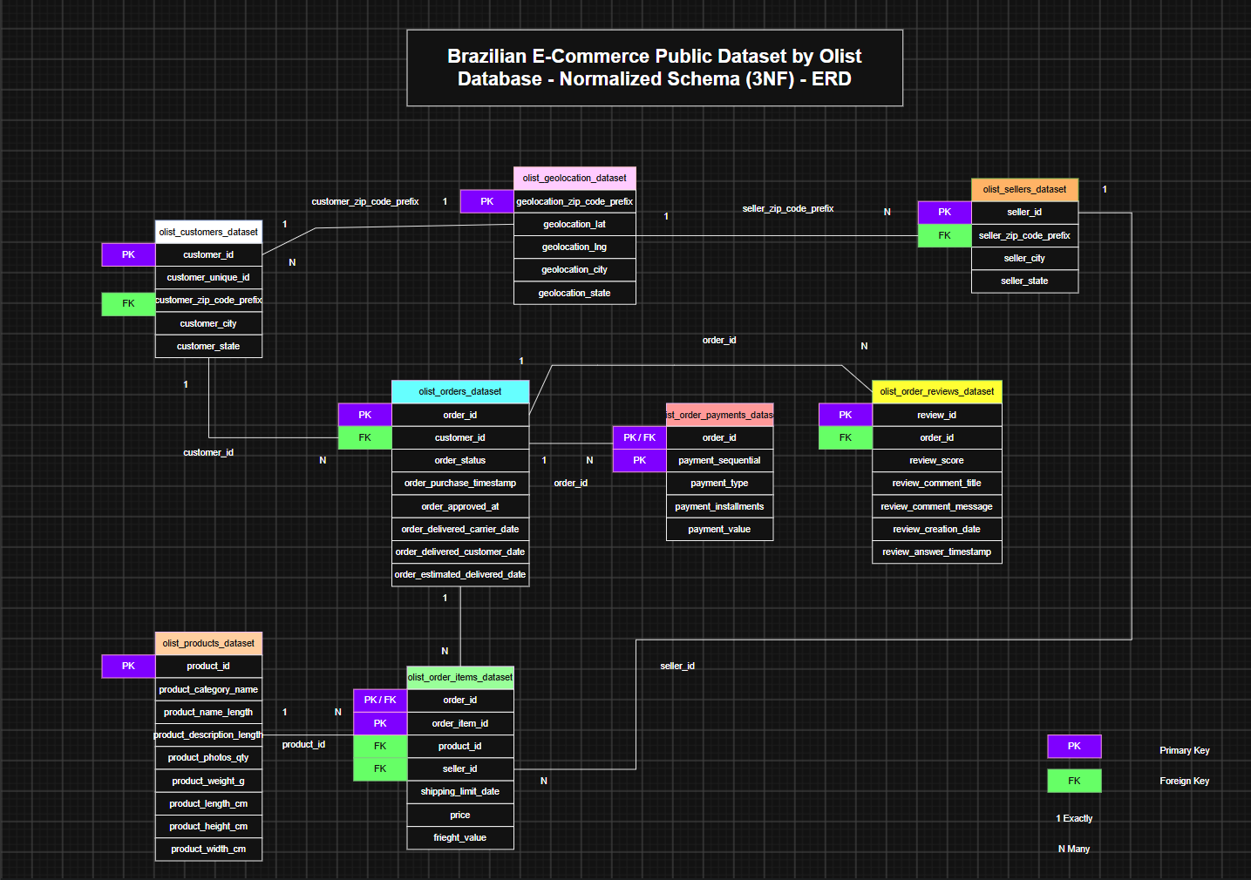

- Identify and document 10+ data quality issues in the raw CSV files.

- NULL values in product_category_name
The product_category_name column in olist_products_dataset contain NULL values.
- Incorrect character encoding in city names
The geolocation_city column in olist_geolocation_dataset contains incorrectly encoded characters. For example, sÃ£o paulo appears instead of são paulo.
- NULL values in review titles
The review_comment_title column in olist_order_reviews_dataset contains multiple NULL values.
- NULL values in review messages
The review_comment_message column in olist_order_reviews_dataset contains multiple NULL values.
- Potential inconsistency in cancelled orders
The order_estimated_delivery_date column in olist_orders_dataset is populated for some orders with order_status = cancelled. This should be validated to determine whether the estimated delivery date should be retained for cancelled orders.
- NULL values in product photo quantity
The product_photos_qty column in olist_products_dataset contains NULL values.
- NULL values in product name length
The product_name_length column in olist_products_dataset contains NULL values.
- NULL values in product description length
The product_description_length column in olist_products_dataset contains NULL values.
- Invalid/numeric values in seller city
The seller_city column in olist_sellers_dataset contains numeric/invalid values where city names are expected.
- Duplicate records in order items
Duplicate rows are present in olist_order_items_dataset, indicating potential duplication in the raw data.
- Inconsistent capitalization in city names
The geolocation_city column in olist_geolocation_dataset contains city names with inconsistent capitalization, such as sao paulo and SAO PAULO. This can cause inconsistencies during grouping, filtering, and analysis.

- Create tables with appropriate data types, primary keys, foreign keys, and constraints.

Created Database, Use Database, Created Tables, Inserted CSV data using CMD command Prompt
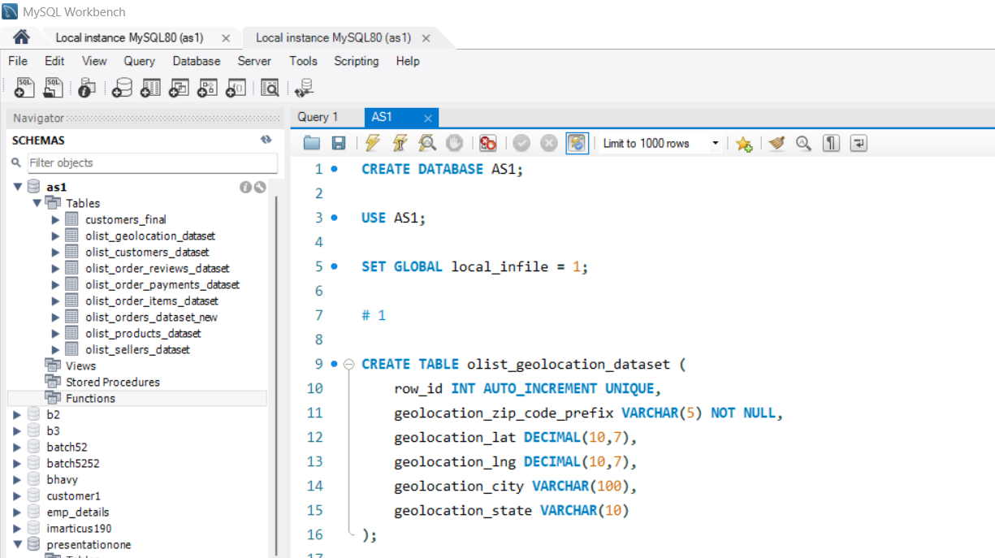

- Write a SQL script to detect and remove duplicate customers while keeping the most recent record.

SELECT
customer_unique_id,
COUNT(*) AS duplicate_count
FROM olist_customers_dataset
GROUP BY customer_unique_id
HAVING COUNT(*) > 1;

SELECT *
FROM olist_customers_dataset
WHERE customer_unique_id IN (
SELECT customer_unique_id
FROM olist_customers_dataset
GROUP BY customer_unique_id
HAVING COUNT(*) > 1
)
ORDER BY customer_unique_id, row_id;

WITH ranked_customers AS (
SELECT
row_id,
customer_unique_id,
ROW_NUMBER() OVER (
PARTITION BY customer_unique_id
ORDER BY row_id DESC
) AS rn
FROM olist_customers_dataset
)
SELECT *
FROM ranked_customers
WHERE rn > 1;

CREATE TEMPORARY TABLE duplicate_customers AS
SELECT row_id
FROM (
SELECT
row_id,
ROW_NUMBER() OVER (
PARTITION BY customer_unique_id
ORDER BY row_id DESC
) AS rn
FROM olist_customers_dataset
) AS ranked
WHERE rn > 1;

DELETE FROM olist_customers_dataset
WHERE row_id IN (
SELECT row_id
FROM duplicate_customers
);

SELECT
customer_unique_id,
COUNT(*) AS count
FROM olist_customers_dataset
GROUP BY customer_unique_id
HAVING COUNT(*) > 1;

SELECT COUNT(*) AS remaining_customers
FROM olist_customers_dataset;

- Create a comprehensive data dictionary documenting each table, column, data type, and business meaning.

Data Dictionary – Olist E-Commerce Database
1. olist_geolocation_dataset
Column | Data Type | Business Meaning
row_id | INT | Auto-generated row identifier used to uniquely identify an imported record.
geolocation_zip_code_prefix | VARCHAR(5) | First five digits of the Brazilian postal code used to identify a geographic area.
geolocation_lat | DECIMAL(10,7) | Latitude coordinate of the geographic location.
geolocation_lng | DECIMAL(10,7) | Longitude coordinate of the geographic location.
geolocation_city | VARCHAR(100) | City associated with the postal code.
geolocation_state | VARCHAR(10) | Brazilian state associated with the location.

2. olist_products_dataset
Column | Data Type | Business Meaning
row_id | INT | Auto-generated row identifier for the imported product record.
product_id | VARCHAR(32) | Unique identifier of the product.
product_category_name | VARCHAR(100) | Category to which the product belongs.
product_name_length | INT | Number of characters in the product name.
product_description_length | INT | Number of characters in the product description.
product_photos_qty | INT | Number of photographs available for the product.
product_weight_g | INT | Product weight in grams.
product_length_cm | INT | Product length in centimeters.
product_height_cm | INT | Product height in centimeters.
product_width_cm | INT | Product width in centimeters.

3. olist_customers_dataset
Column | Data Type | Business Meaning
row_id | INT | Auto-generated row identifier for the imported customer record.
customer_id | VARCHAR(32) | Identifier assigned to a customer for an order.
customer_unique_id | VARCHAR(32) | Unique identifier representing the customer across orders.
customer_zip_code_prefix | VARCHAR(5) | First five digits of the customer's postal code.
customer_city | VARCHAR(100) | City where the customer is located.
customer_state | VARCHAR(10) | Brazilian state where the customer is located.
Important: customer_id identifies a customer record associated with an order, while customer_unique_id is used to identify the actual customer across multiple orders.

4. olist_sellers_dataset
Column | Data Type | Business Meaning
row_id | INT | Auto-generated row identifier for the imported seller record.
seller_id | VARCHAR(32) | Unique identifier of the seller.
seller_zip_code_prefix | VARCHAR(5) | First five digits of the seller's postal code.
seller_city | VARCHAR(100) | City where the seller is located.
seller_state | VARCHAR(10) | Brazilian state where the seller is located.

5. olist_orders_dataset
Column | Data Type | Business Meaning
row_id | INT | Auto-generated row identifier for the imported order record.
order_id | VARCHAR(32) | Unique identifier of an order.
customer_id | VARCHAR(32) | Identifier of the customer who placed the order.
order_status | VARCHAR(30) | Current status of the order, such as delivered, shipped, canceled, etc.
order_purchase_timestamp | DATETIME | Date and time when the customer placed the order.
order_approved_at | DATETIME | Date and time when the payment/order was approved.
order_delivered_carrier_date | DATETIME | Date and time when the order was handed over to the carrier.
order_delivered_customer_date | DATETIME | Date and time when the order was delivered to the customer.
order_estimated_delivery_date | DATETIME | Estimated date on which the order was expected to be delivered.

6. olist_order_items_dataset
Column | Data Type | Business Meaning
row_id | INT | Auto-generated row identifier for the imported order-item record.
order_id | VARCHAR(32) | Identifier of the order containing the item.
order_item_id | INT | Sequential number identifying an item within an order.
product_id | VARCHAR(32) | Identifier of the product purchased.
seller_id | VARCHAR(32) | Identifier of the seller who sold the product.
shipping_limit_date | DATETIME | Deadline by which the seller should ship the item.
price | DECIMAL(10,2) | Price of the purchased product.
freight_value | DECIMAL(10,2) | Shipping/freight cost charged for the item.

7. olist_order_payments_dataset
Column | Data Type | Business Meaning
row_id | INT | Auto-generated row identifier for the imported payment record.
order_id | VARCHAR(32) | Identifier of the order associated with the payment.
payment_sequential | INT | Sequential number of a payment within an order.
payment_type | VARCHAR(30) | Payment method used, such as credit card, boleto, voucher, or debit card.
payment_installments | INT | Number of installments used for the payment.
payment_value | DECIMAL(10,2) | Monetary value of the payment.

8. olist_order_reviews_dataset
Column | Data Type | Business Meaning
row_id | INT | Auto-generated row identifier for the imported review record.
review_id | VARCHAR(32) | Identifier of the customer review.
order_id | VARCHAR(32) | Identifier of the order being reviewed.
review_score | INT | Customer rating given to the order, typically from 1 to 5.
review_comment_title | VARCHAR(255) | Short title/headline provided with the review.
review_comment_message | TEXT | Detailed written feedback provided by the customer.
review_creation_date | DATETIME | Date and time when the review was created.
review_answer_timestamp | DATETIME | Date and time when the review was answered.

Part B: Data Manipulation & Retrieval (5 Questions)
- Insert cleaned data using transactions and demonstrate COMMIT and ROLLBACK.

SET autocommit = 0;

START TRANSACTION;

CREATE TABLE customers_final (
customer_id VARCHAR(32) PRIMARY KEY,
customer_unique_id VARCHAR(32) NOT NULL,
customer_zip_code_prefix VARCHAR(5),
customer_city VARCHAR(100),
customer_state VARCHAR(10)
);

INSERT INTO customers_final (
customer_id,
customer_unique_id,
customer_zip_code_prefix,
customer_city,
customer_state
)
SELECT
customer_id,
customer_unique_id,
customer_zip_code_prefix,
customer_city,
customer_state
FROM olist_customers_dataset;

SELECT COUNT(*) FROM customers_final;

ROLLBACK;
SELECT COUNT(*) FROM customers_final;

START TRANSACTION;

INSERT INTO customers_final (
customer_id,
customer_unique_id,
customer_zip_code_prefix,
customer_city,
customer_state
)
SELECT
customer_id,
customer_unique_id,
customer_zip_code_prefix,
customer_city,
customer_state
FROM olist_customers_dataset;

SELECT COUNT(*) FROM customers_final;

COMMIT;

SELECT COUNT(*) FROM customers_final;

SET autocommit = 1;

- Find customers who have the same email but different names/addresses.

NO VALID COLUMNS

- Identify orphan records referencing non-existent products or orders.

no orphan records were found.

- List customers who registered but never placed an order.

No customers were found who registered but never placed an order.

- Detect potential fraud where payment value differs from order total.
303 orders were identified where the total payment value differs from the calculated order total (price + freight_value) by more than 0.01.

WITH order_totals AS (
SELECT
order_id,
SUM(price + freight_value) AS order_total
FROM olist_order_items_dataset
GROUP BY order_id
),
payment_totals AS (
SELECT
order_id,
SUM(payment_value) AS payment_total
FROM olist_order_payments_dataset
GROUP BY order_id
)
SELECT
o.order_id,
ROUND(o.order_total, 2) AS order_total,
ROUND(p.payment_total, 2) AS payment_total,
ROUND(p.payment_total - o.order_total, 2) AS difference
FROM order_totals AS o
JOIN payment_totals AS p
ON o.order_id = p.order_id
WHERE ABS(p.payment_total - o.order_total) > 0.01
ORDER BY ABS(p.payment_total - o.order_total) DESC;
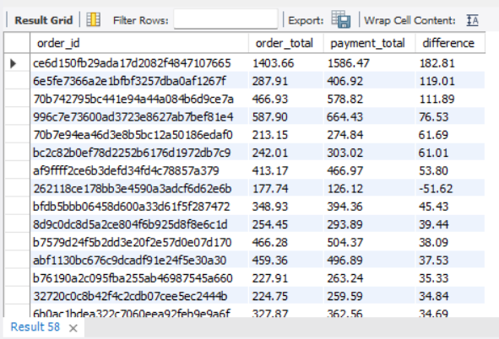
Part C: Complex Aggregations (5 Questions)
- Calculate monthly revenue with Month-over-Month growth percentage.

WITH monthly_revenue AS (
SELECT
DATE_FORMAT(o.order_purchase_timestamp, '%Y-%m') AS month,
SUM(oi.price + oi.freight_value) AS revenue
FROM olist_orders_dataset_new AS o
JOIN olist_order_items_dataset AS oi
ON o.order_id = oi.order_id
GROUP BY DATE_FORMAT(o.order_purchase_timestamp, '%Y-%m')
),
monthly_growth AS (
SELECT
month,
revenue,
LAG(revenue) OVER (ORDER BY month) AS previous_month_revenue
FROM monthly_revenue
)
SELECT
month,
ROUND(revenue, 2) AS revenue,
ROUND(previous_month_revenue, 2) AS previous_month_revenue,
ROUND(
((revenue - previous_month_revenue)
/ previous_month_revenue) * 100,
2
) AS mom_growth_percentage
FROM monthly_growth
ORDER BY month;
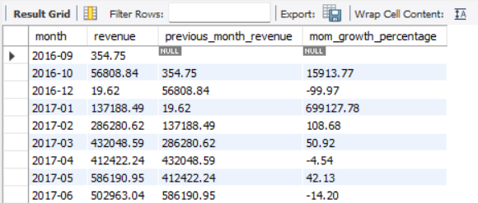
- Find top 10 products by revenue in each category.
WITH product_revenue AS (
SELECT
p.product_category_name,
oi.product_id,
SUM(oi.price) AS revenue
FROM olist_order_items_dataset AS oi
JOIN olist_products_dataset AS p
ON oi.product_id = p.product_id
GROUP BY
p.product_category_name,
oi.product_id
),
ranked_products AS (
SELECT
product_category_name,
product_id,
revenue,
ROW_NUMBER() OVER (
PARTITION BY product_category_name
ORDER BY revenue DESC
) AS product_rank
FROM product_revenue
)
SELECT
product_category_name,
product_id,
ROUND(revenue, 2) AS revenue,
product_rank
FROM ranked_products
WHERE product_rank <= 10
ORDER BY
product_category_name,
product_rank;
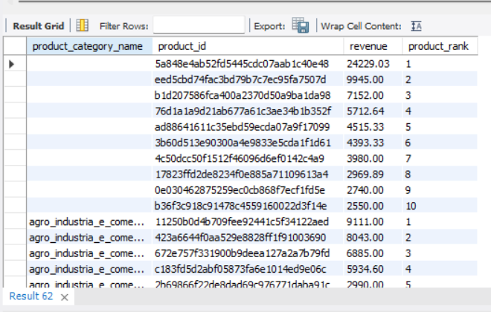

- Calculate Customer Lifetime Value (CLV) and categorize customers.

Step 1 — Calculate each customer's total spending

WITH customer_spending AS (
SELECT
o.customer_id,
SUM(oi.price + oi.freight_value) AS total_spending
FROM olist_orders_dataset AS o
JOIN olist_order_items_dataset AS oi
ON o.order_id = oi.order_id
GROUP BY o.customer_id
)
SELECT
customer_id,
ROUND(total_spending, 2) AS CLV
FROM customer_spending
ORDER BY CLV DESC;
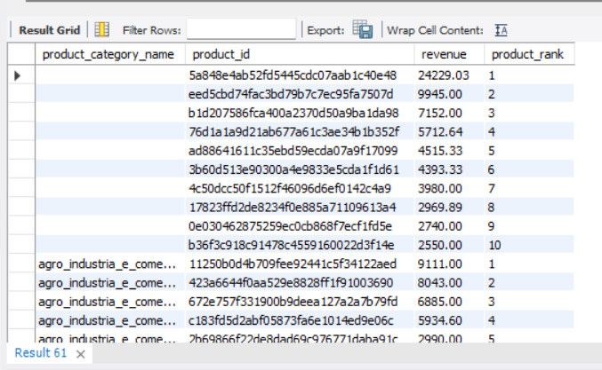

Step 2 — Categorize customers

WITH customer_spending AS (
SELECT
o.customer_id,
SUM(oi.price + oi.freight_value) AS CLV
FROM olist_orders_dataset AS o
JOIN olist_order_items_dataset AS oi
ON o.order_id = oi.order_id
GROUP BY o.customer_id
)
SELECT
customer_id,
ROUND(CLV, 2) AS CLV,
CASE
WHEN CLV >= 1000 THEN 'High Value'
WHEN CLV >= 500 THEN 'Medium Value'
ELSE 'Low Value'
END AS customer_category
FROM customer_spending
ORDER BY CLV DESC;
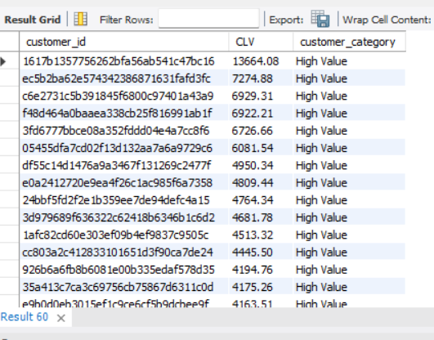

- Create sales reports using ROLLUP or CUBE.

SELECT
YEAR(o.order_purchase_timestamp) AS year,
MONTH(o.order_purchase_timestamp) AS month,
ROUND(SUM(oi.price + oi.freight_value), 2) AS total_sales
FROM olist_orders_dataset_new AS o
JOIN olist_order_items_dataset AS oi
ON o.order_id = oi.order_id
GROUP BY
YEAR(o.order_purchase_timestamp),
MONTH(o.order_purchase_timestamp)
WITH ROLLUP;

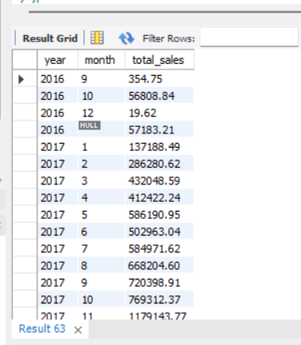

- Identify seasonal sales patterns by product category.

SELECT
MONTH(o.order_purchase_timestamp) AS month,
p.product_category_name,
ROUND(SUM(oi.price + oi.freight_value), 2) AS total_sales
FROM olist_orders_dataset_new AS o
JOIN olist_order_items_dataset AS oi
ON o.order_id = oi.order_id
JOIN olist_products_dataset AS p
ON oi.product_id = p.product_id
GROUP BY
MONTH(o.order_purchase_timestamp),
p.product_category_name
ORDER BY
p.product_category_name,
month;
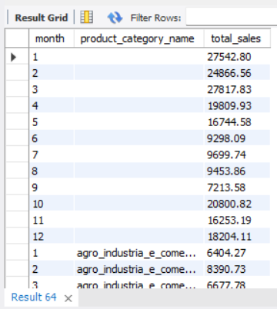

Part D: Mastering Joins (5 Questions)
- Create a customer 360-degree view joining multiple tables.

SELECT
c.customer_id,
c.customer_unique_id,
c.customer_city,
c.customer_state,

o.order_id,
o.order_status,
o.order_purchase_timestamp,

oi.product_id,
p.product_category_name,
oi.price,
oi.freight_value,

pay.payment_type,
pay.payment_value,

r.review_score

FROM olist_customers_dataset AS c

LEFT JOIN olist_orders_dataset AS o
ON c.customer_id = o.customer_id

LEFT JOIN olist_order_items_dataset AS oi
ON o.order_id = oi.order_id

LEFT JOIN olist_products_dataset AS p
ON oi.product_id = p.product_id

LEFT JOIN olist_order_payments_dataset AS pay
ON o.order_id = pay.order_id

LEFT JOIN olist_order_reviews_dataset AS r
ON o.order_id = r.order_id

ORDER BY c.customer_id, o.order_purchase_timestamp;
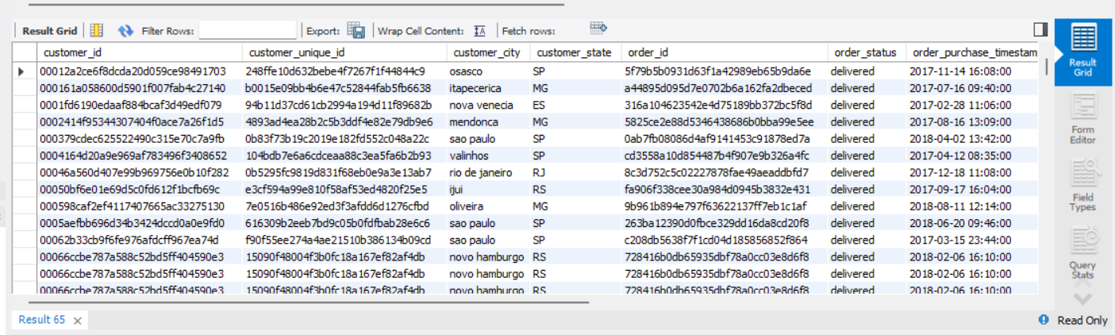

- Find customers who bought electronics but never books.

SELECT DISTINCT
c.customer_id,
c.customer_unique_id,
c.customer_city,
c.customer_state
FROM olist_customers_dataset AS c
JOIN olist_orders_dataset_new AS o
ON c.customer_id = o.customer_id
JOIN olist_order_items_dataset AS oi
ON o.order_id = oi.order_id
JOIN olist_products_dataset AS p
ON oi.product_id = p.product_id
WHERE p.product_category_name LIKE '%eletron%'
AND c.customer_id NOT IN (
SELECT DISTINCT o2.customer_id
FROM olist_orders_dataset_new AS o2
JOIN olist_order_items_dataset AS oi2
ON o2.order_id = oi2.order_id
JOIN olist_products_dataset AS p2
ON oi2.product_id = p2.product_id
WHERE p2.product_category_name LIKE '%livro%'
);
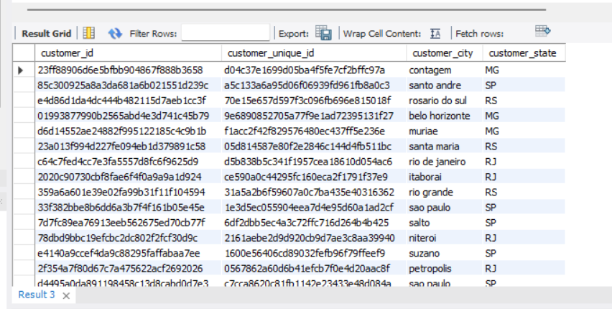
- List sellers and their best-selling product in each category.

WITH product_sales AS (
SELECT
oi.seller_id,
p.product_category_name,
oi.product_id,
COUNT(*) AS units_sold
FROM olist_order_items_dataset AS oi
JOIN olist_products_dataset AS p
ON oi.product_id = p.product_id
GROUP BY
oi.seller_id,
p.product_category_name,
oi.product_id
),
ranked_products AS (
SELECT
seller_id,
product_category_name,
product_id,
units_sold,
ROW_NUMBER() OVER (
PARTITION BY seller_id, product_category_name
ORDER BY units_sold DESC
) AS product_rank
FROM product_sales
)
SELECT
seller_id,
product_category_name,
product_id,
units_sold
FROM ranked_products
WHERE product_rank = 1
ORDER BY
seller_id,
product_category_name,
units_sold DESC;
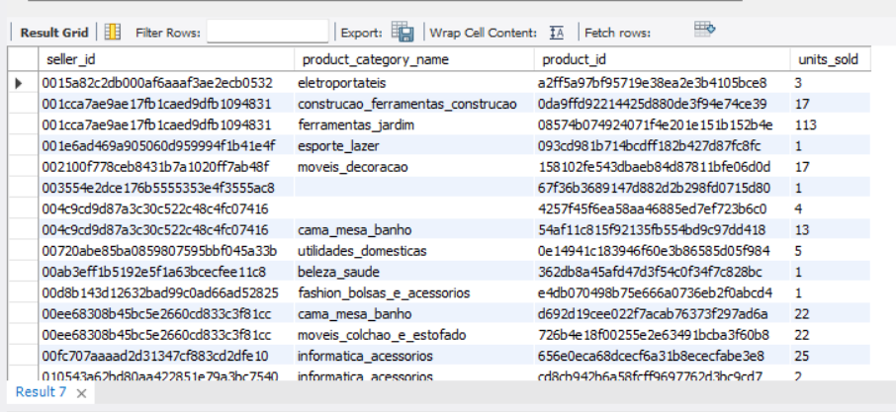

- Perform market basket analysis using self-joins.

SELECT
oi1.product_id AS product_1,
oi2.product_id AS product_2,
COUNT(DISTINCT oi1.order_id) AS times_bought_together
FROM olist_order_items_dataset AS oi1
JOIN olist_order_items_dataset AS oi2
ON oi1.order_id = oi2.order_id
AND oi1.product_id < oi2.product_id
GROUP BY
oi1.product_id,
oi2.product_id
ORDER BY
times_bought_together DESC;
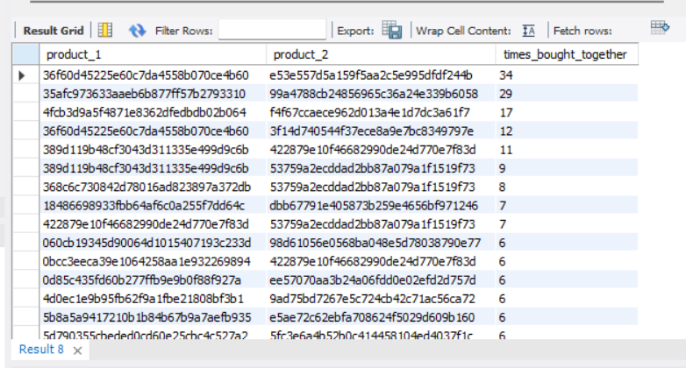

- Identify orders with shipping delays.

SELECT
order_id,
order_status,
order_delivered_customer_date,
order_estimated_delivery_date,
DATEDIFF(
STR_TO_DATE(order_delivered_customer_date, '%d-%m-%Y %H:%i'),
STR_TO_DATE(order_estimated_delivery_date, '%d-%m-%Y %H:%i')
) AS delay_days
FROM olist_orders_dataset_new
WHERE STR_TO_DATE(order_delivered_customer_date, '%d-%m-%Y %H:%i')
> STR_TO_DATE(order_estimated_delivery_date, '%d-%m-%Y %H:%i')
ORDER BY delay_days DESC;

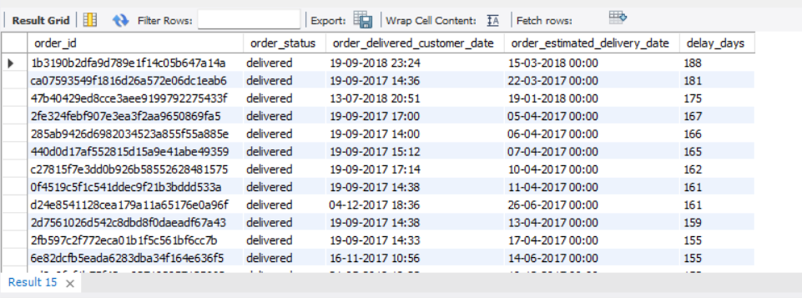

Part E: Subqueries & CTEs (4 Questions)
- Find customers spending above their state's average.

WITH customer_spending AS (
SELECT
c.customer_id,
c.customer_state,
SUM(oi.price + oi.freight_value) AS total_spending
FROM olist_customers_dataset AS c
JOIN olist_orders_dataset_new AS o
ON c.customer_id = o.customer_id
JOIN olist_order_items_dataset AS oi
ON o.order_id = oi.order_id
GROUP BY
c.customer_id,
c.customer_state
),
state_average AS (
SELECT
customer_state,
AVG(total_spending) AS avg_state_spending
FROM customer_spending
GROUP BY customer_state
)
SELECT
cs.customer_id,
cs.customer_state,
ROUND(cs.total_spending, 2) AS total_spending,
ROUND(sa.avg_state_spending, 2) AS state_average
FROM customer_spending AS cs
JOIN state_average AS sa
ON cs.customer_state = sa.customer_state
WHERE cs.total_spending > sa.avg_state_spending
ORDER BY cs.customer_state, cs.total_spending DESC;
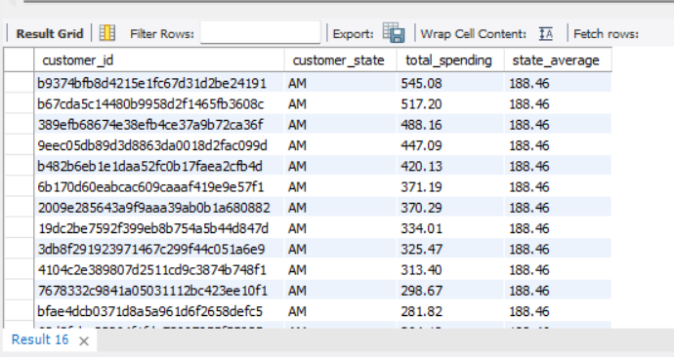

- Get the 2nd highest revenue-generating product in each category.

WITH product_revenue AS (
SELECT
p.product_category_name,
oi.product_id,
SUM(oi.price + oi.freight_value) AS revenue
FROM olist_order_items_dataset AS oi
JOIN olist_products_dataset AS p
ON oi.product_id = p.product_id
GROUP BY
p.product_category_name,
oi.product_id
),
ranked_products AS (
SELECT
product_category_name,
product_id,
revenue,
DENSE_RANK() OVER (
PARTITION BY product_category_name
ORDER BY revenue DESC
) AS revenue_rank
FROM product_revenue
)
SELECT
product_category_name,
product_id,
ROUND(revenue, 2) AS revenue
FROM ranked_products
WHERE revenue_rank = 2
ORDER BY product_category_name;

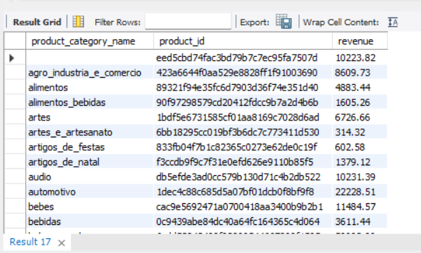

- Create a product category hierarchy using recursive CTEs.

Skipped
- Find customers purchasing in 3+ consecutive months.

WITH customer_months AS (
SELECT DISTINCT
customer_id,
DATE_FORMAT(order_purchase_timestamp, '%Y-%m') AS purchase_month
FROM olist_orders_dataset_new
),
numbered_months AS (
SELECT
customer_id,
purchase_month,
LAG(purchase_month, 1) OVER (
PARTITION BY customer_id
ORDER BY purchase_month
) AS previous_month,
LAG(purchase_month, 2) OVER (
PARTITION BY customer_id
ORDER BY purchase_month
) AS two_months_before
FROM customer_months
)
SELECT DISTINCT
customer_id,
purchase_month
FROM numbered_months
WHERE TIMESTAMPDIFF(
MONTH,
STR_TO_DATE(two_months_before, '%Y-%m'),
STR_TO_DATE(purchase_month, '%Y-%m')
) = 2
AND TIMESTAMPDIFF(
MONTH,
STR_TO_DATE(previous_month, '%Y-%m'),
STR_TO_DATE(purchase_month, '%Y-%m')
) = 1
ORDER BY customer_id, purchase_month;
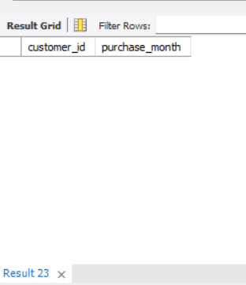
No customers were found who made purchases in three or more consecutive calendar months.

Part F: Advanced Window Functions (4 Questions)
- Calculate a 7-day moving average of daily order count.

WITH daily_orders AS (
SELECT
DATE(order_purchase_timestamp) AS order_date,
COUNT(DISTINCT order_id) AS order_count
FROM olist_orders_dataset_new
GROUP BY DATE(order_purchase_timestamp)
)
SELECT
order_date,
order_count,
ROUND(
AVG(order_count) OVER (
ORDER BY order_date
ROWS BETWEEN 6 PRECEDING AND CURRENT ROW
),
2
) AS moving_avg_7_days
FROM daily_orders
ORDER BY order_date;

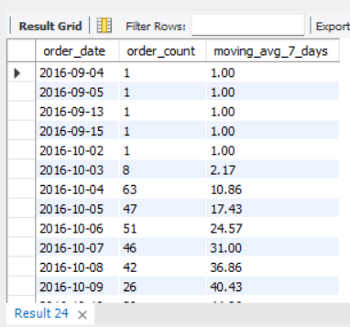

- Find gaps between consecutive customer orders using LAG().

WITH customer_orders AS (
SELECT
customer_id,
order_id,
order_purchase_timestamp,
LAG(order_purchase_timestamp) OVER (
PARTITION BY customer_id
ORDER BY order_purchase_timestamp
) AS previous_order_date
FROM olist_orders_dataset_new
)
SELECT
customer_id,
order_id,
order_purchase_timestamp,
previous_order_date,
DATEDIFF(
order_purchase_timestamp,
previous_order_date
) AS gap_days
FROM customer_orders
WHERE previous_order_date IS NOT NULL
ORDER BY customer_id, order_purchase_timestamp;

No consecutive customer orders were found;
therefore, no order gaps could be calculated.

- Rank sellers by revenue within each state.

WITH seller_revenue AS (
SELECT
s.seller_id,
s.seller_state,
SUM(oi.price + oi.freight_value) AS revenue
FROM olist_sellers_dataset AS s
JOIN olist_order_items_dataset AS oi
ON s.seller_id = oi.seller_id
GROUP BY
s.seller_id,
s.seller_state
)
SELECT
seller_id,
seller_state,
ROUND(revenue, 2) AS revenue,
RANK() OVER (
PARTITION BY seller_state
ORDER BY revenue DESC
) AS seller_rank
FROM seller_revenue
ORDER BY seller_state, seller_rank;
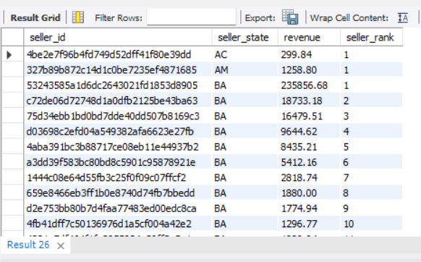
- Calculate running revenue totals and percentage contribution.

WITH monthly_revenue AS (
SELECT
DATE_FORMAT(o.order_purchase_timestamp, '%Y-%m') AS month,
SUM(oi.price + oi.freight_value) AS revenue
FROM olist_orders_dataset_new AS o
JOIN olist_order_items_dataset AS oi
ON o.order_id = oi.order_id
GROUP BY DATE_FORMAT(o.order_purchase_timestamp, '%Y-%m')
)
SELECT
month,
ROUND(revenue, 2) AS revenue,

ROUND(
SUM(revenue) OVER (
ORDER BY month
ROWS BETWEEN UNBOUNDED PRECEDING AND CURRENT ROW
),
2
) AS running_revenue,

ROUND(
(revenue / SUM(revenue) OVER ()) * 100,
2
) AS percentage_contribution

FROM monthly_revenue
ORDER BY month;
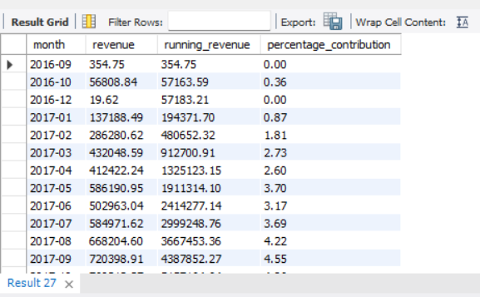

Part G: Stored Procedures & Optimization (2 Questions)
- Create a stored procedure for dynamic discount calculation.

DELIMITER //

CREATE PROCEDURE CalculateDiscount(IN order_amount DECIMAL(10,2))
BEGIN
DECLARE discount_rate DECIMAL(5,2);
DECLARE discount_amount DECIMAL(10,2);
DECLARE final_amount DECIMAL(10,2);

IF order_amount >= 2000 THEN
SET discount_rate = 15;
ELSEIF order_amount >= 1000 THEN
SET discount_rate = 10;
ELSEIF order_amount >= 500 THEN
SET discount_rate = 5;
ELSE
SET discount_rate = 0;
END IF;

SET discount_amount = order_amount * discount_rate / 100;
SET final_amount = order_amount - discount_amount;

SELECT
order_amount AS original_amount,
discount_rate AS discount_percentage,
ROUND(discount_amount, 2) AS discount_amount,
ROUND(final_amount, 2) AS final_amount;
END //

DELIMITER ;

CALL CalculateDiscount(2500);

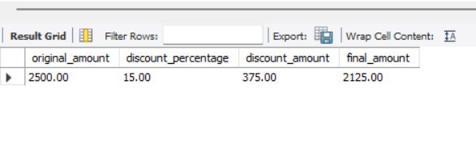

- Optimize slow queries using EXPLAIN ANALYZE and indexes.

SELECT
o.order_id,
o.customer_id,
oi.product_id,
oi.price
FROM olist_orders_dataset_new AS o
JOIN olist_order_items_dataset AS oi
ON o.order_id = oi.order_id
WHERE o.customer_id = '00012a2ce6f8dcda20d059ce98491703';

EXPLAIN ANALYZE
SELECT
o.order_id,
o.customer_id,
oi.product_id,
oi.price
FROM olist_orders_dataset_new AS o
JOIN olist_order_items_dataset AS oi
ON o.order_id = oi.order_id
WHERE o.customer_id = '00012a2ce6f8dcda20d059ce98491703';

CREATE INDEX idx_orders_customer
ON olist_orders_dataset_new(customer_id);

CREATE INDEX idx_items_order
ON olist_order_items_dataset(order_id);

EXPLAIN ANALYZE
SELECT
o.order_id,
o.customer_id,
oi.product_id,
oi.price
FROM olist_orders_dataset_new AS o
JOIN olist_order_items_dataset AS oi
ON o.order_id = oi.order_id
WHERE o.customer_id = '00012a2ce6f8dcda20d059ce98491703';

